1. **find sorted list of students in decreasing manner by their first name.**

Select first_name,last_name from cf_db.students order by first_name desc

**100 rows**

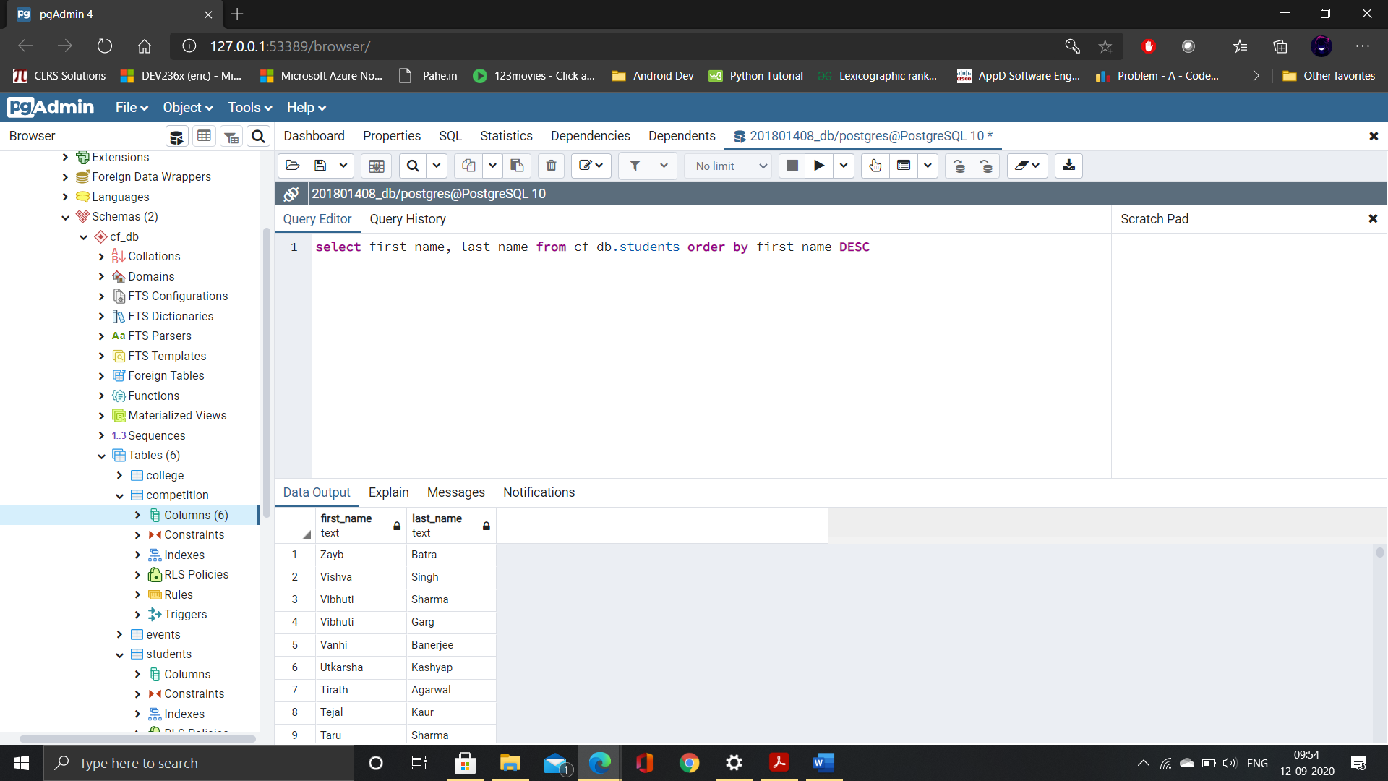

1. **find list of competitions in order by highest to lowest winner price.**

Select co_name from cf_db.competition order by win_price desc

**41 rows**

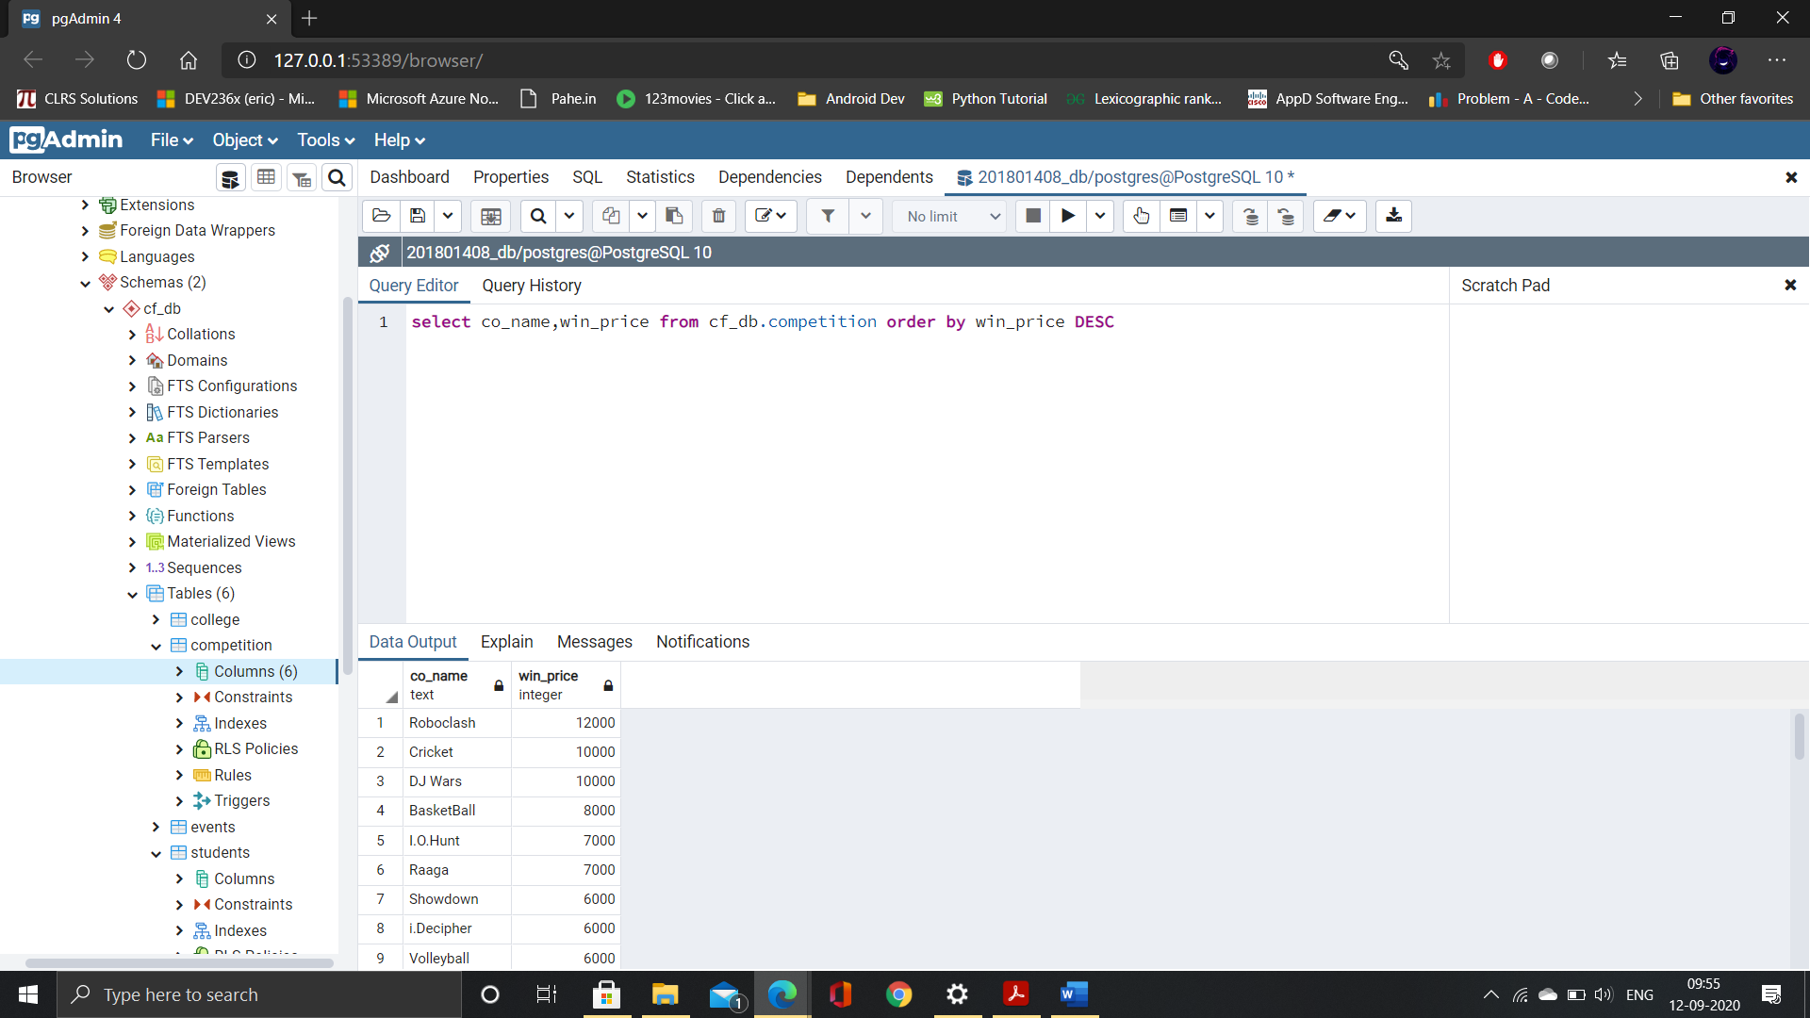

1. **Show the list of team ids which are winners of competitions (1st place)**

Select count(team_id) from cf_db.winners where position=’1’

**19 rows**

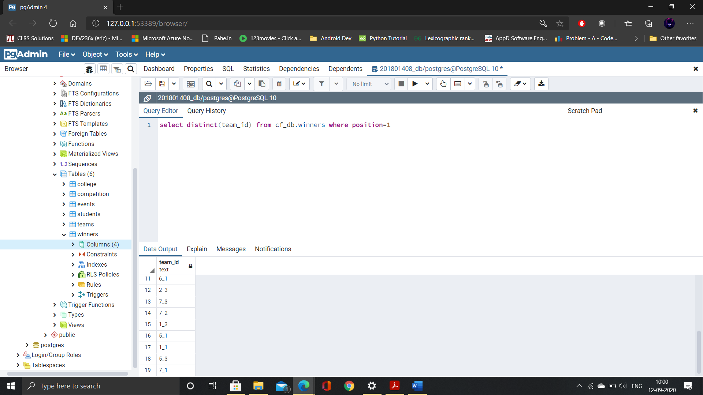

1. **Show list of winning teams with team’s name, strength and position of teams**

Select teams.t_name,teams.t_strength,winners.position from cf_db.teams join

cf_db.winners on teams.team_id=winners.team_id and winners.position=’1’

**41 rows**

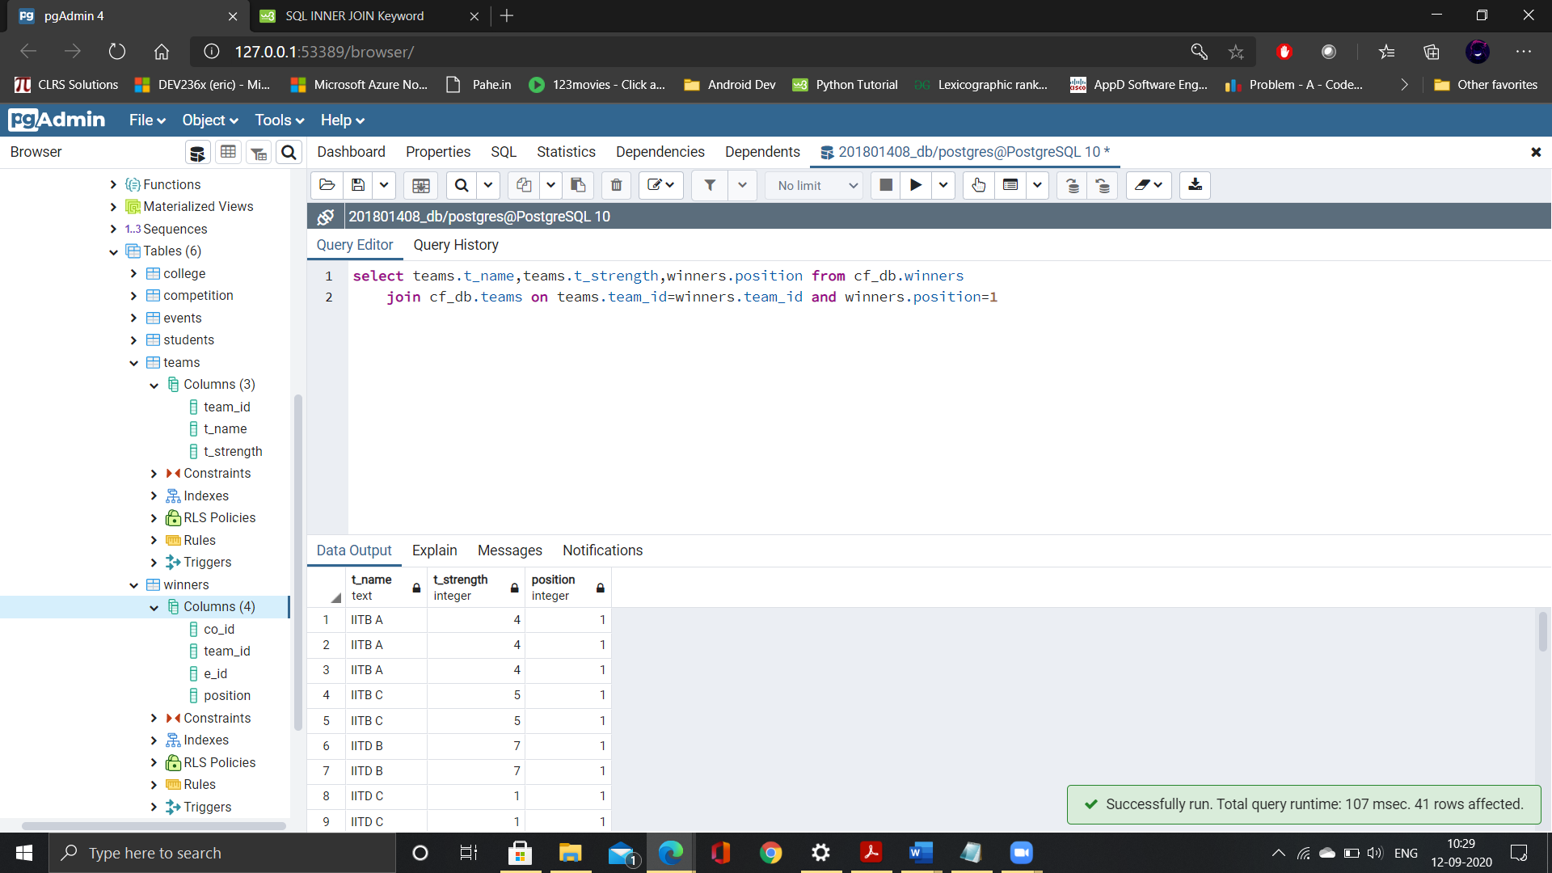

1. **Find the list of ‘Sports’ competitions with name, date and starting time.**

Select co_name,date,time from cf_db.competition join cf_db.events on competition.e_id=events.e_id where e_type=’Sports’

**9 rows**

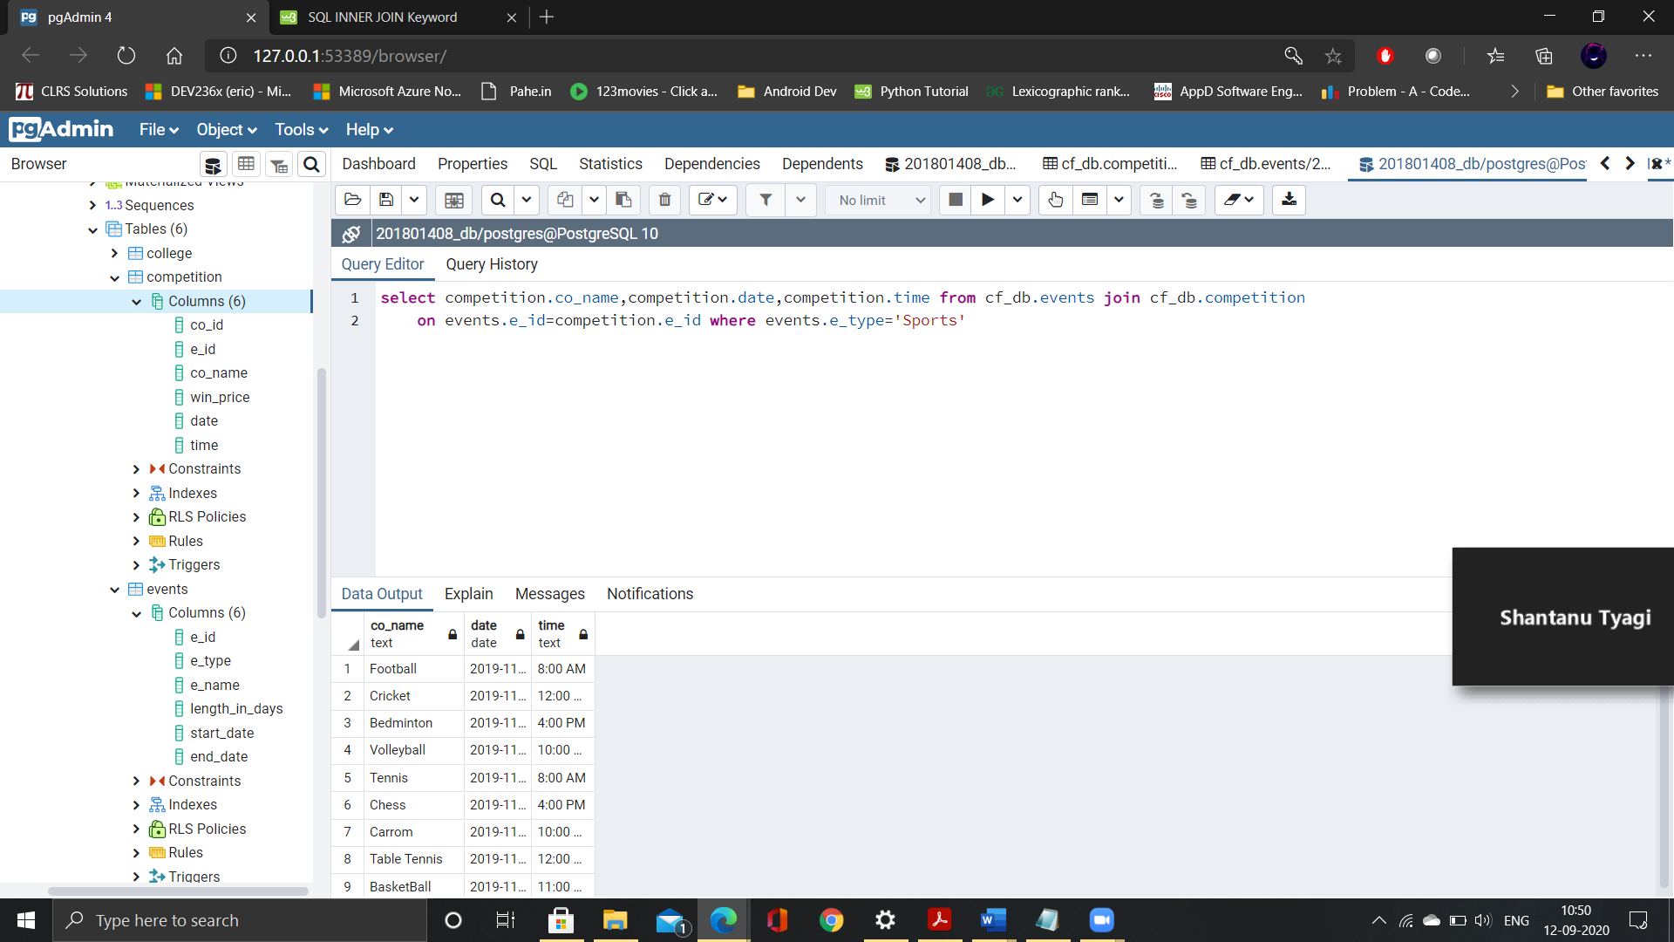

1. **Find the competition list which are held between '11-10-2019' and '13-10-2019' dates.**

Select co_name from cf_db.competition where date between ‘10-11-2019’ and ‘10-13-2019’

**13 rows**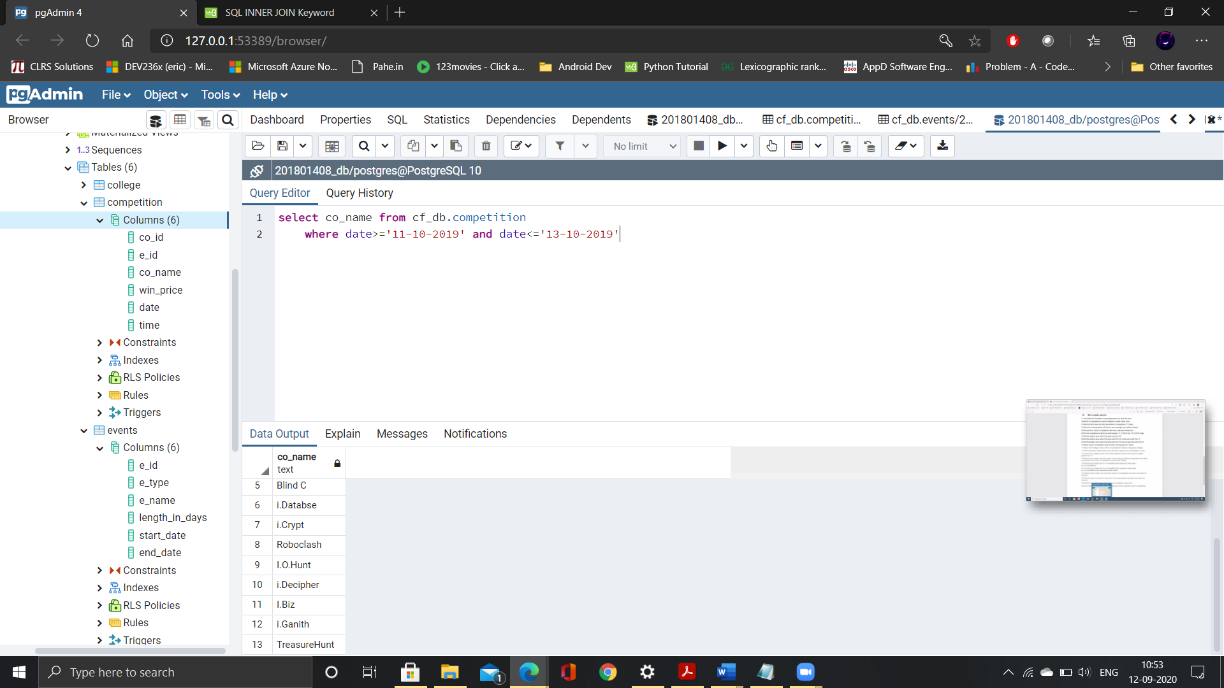

1. **Find the student name which first name start from ‘R’.**

Select first_name,last_name from cf_db.students where first_name like ‘R%’

**13 rows**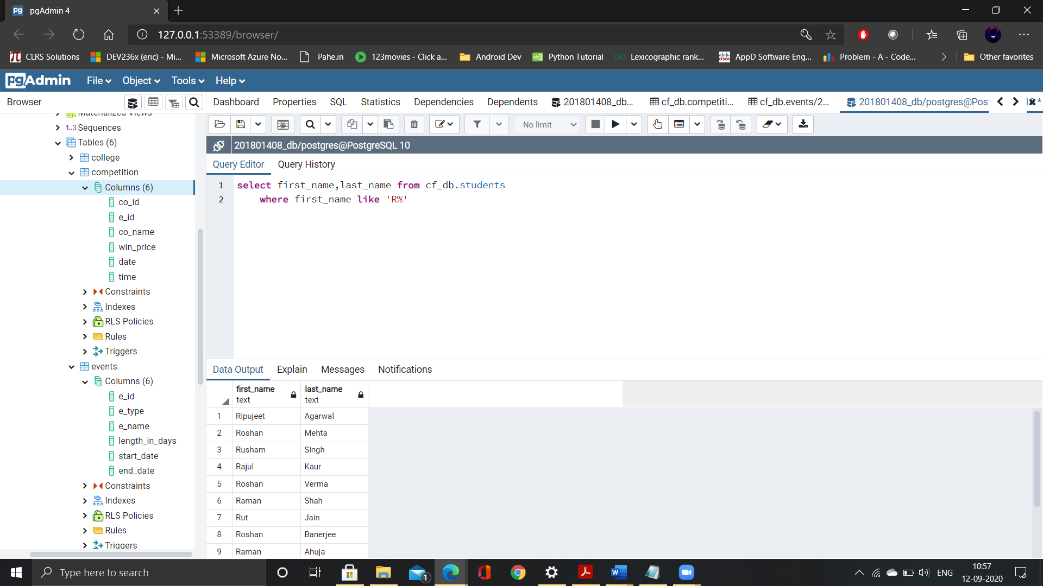

1. **Find the student name which first name start from ‘R’ or last name start from ‘S’.**

Select first_name,last_name from cf_db.students where first_name like ‘R%’ or last_name like ‘S%’

**33 rows**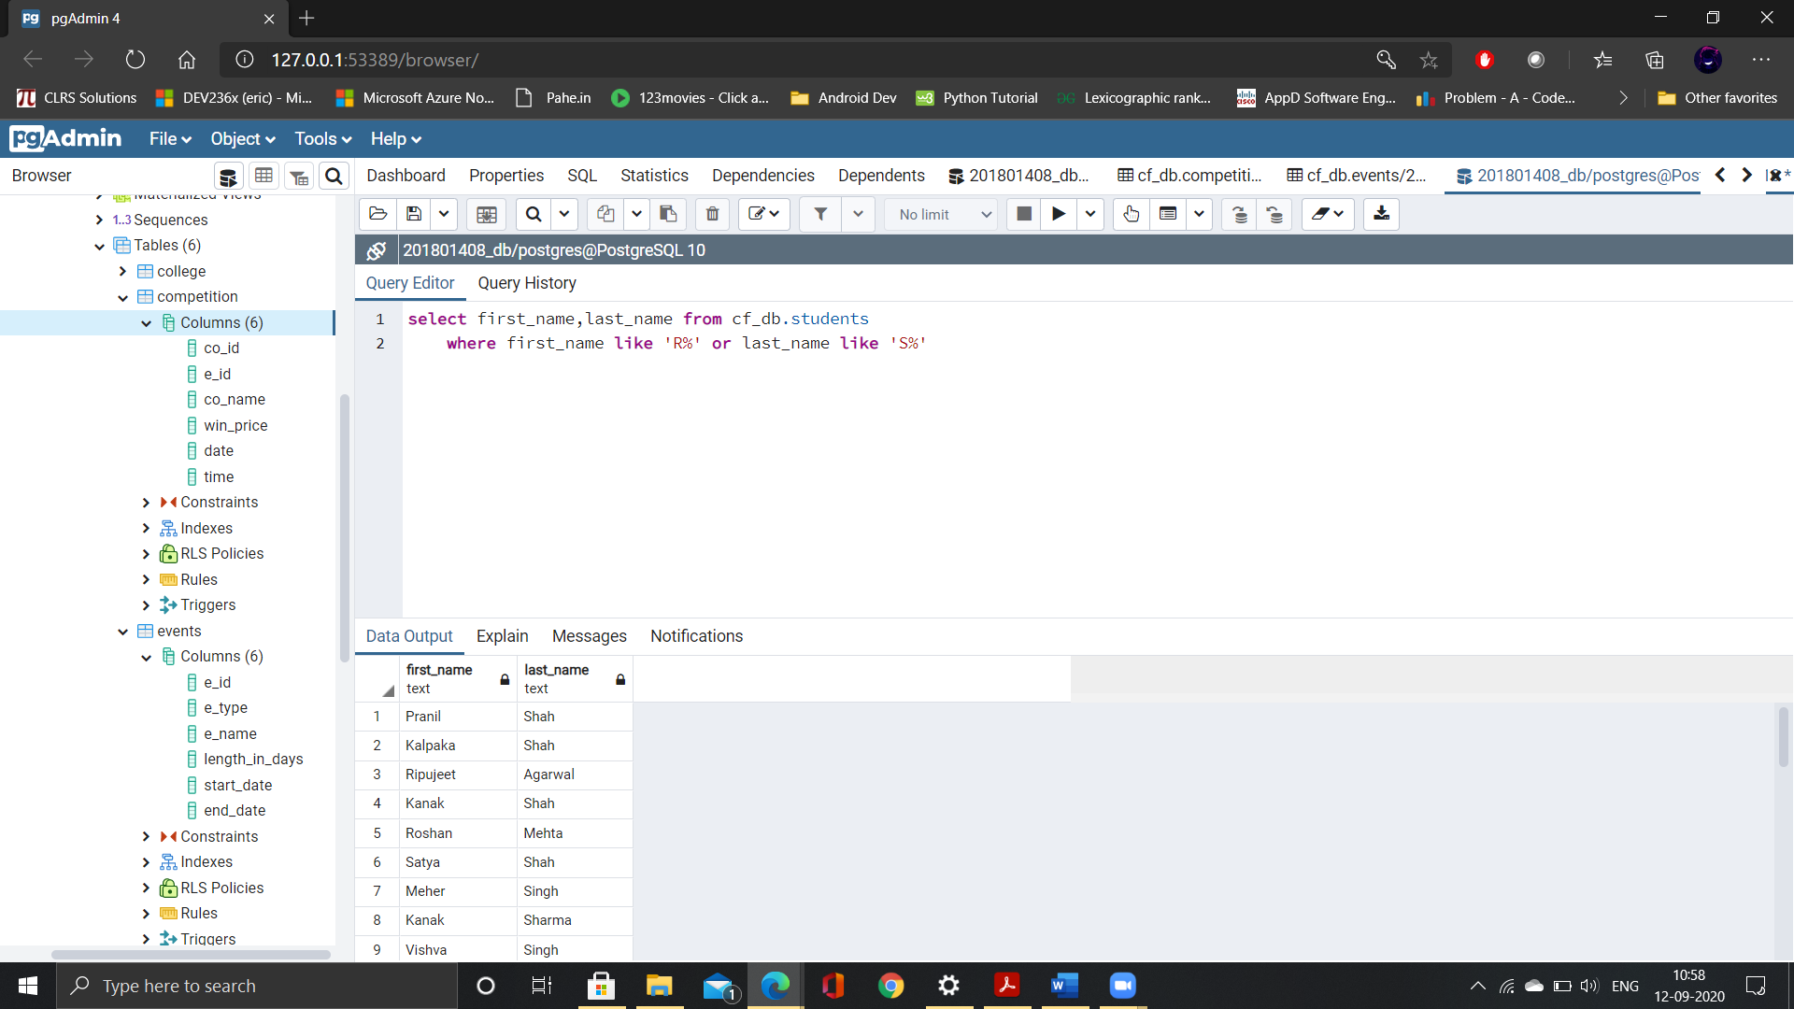

1. **Find the student name which first name start from ‘R’ and not last name start from ‘S’.**

Select distinct(first_name), last_name from cf_db.students where first_name like ‘R%’ and last_name not like ‘S%’

**10 rows**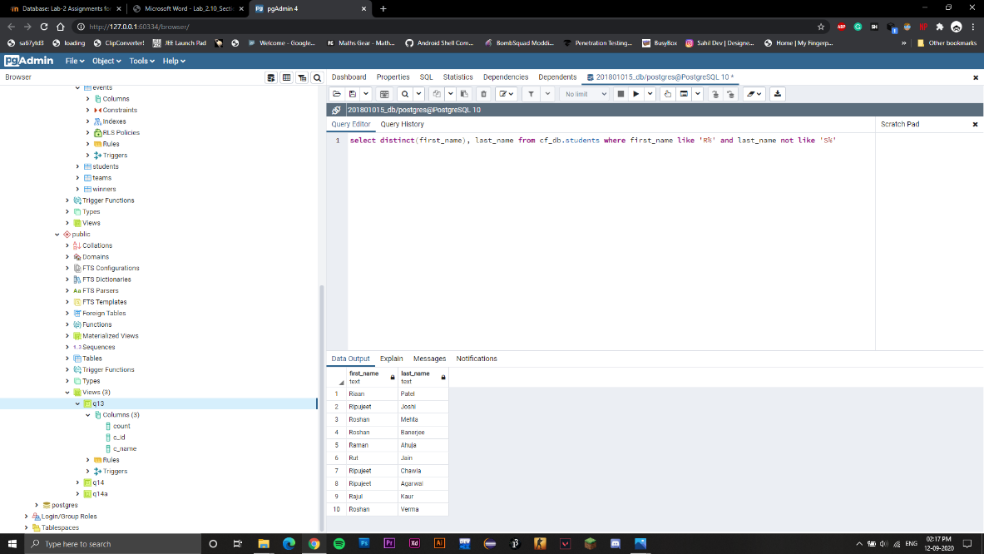

1. **Show the list of competition name and their winning teams (1st place).**

Select competition.co_name,teams.t_name from cf_db.competition join cf_db.winners on competition.co_id=winners.co_id join cf_db.teams on winners.team_id=teams.team_id and winners.position=’1’

**41 rows**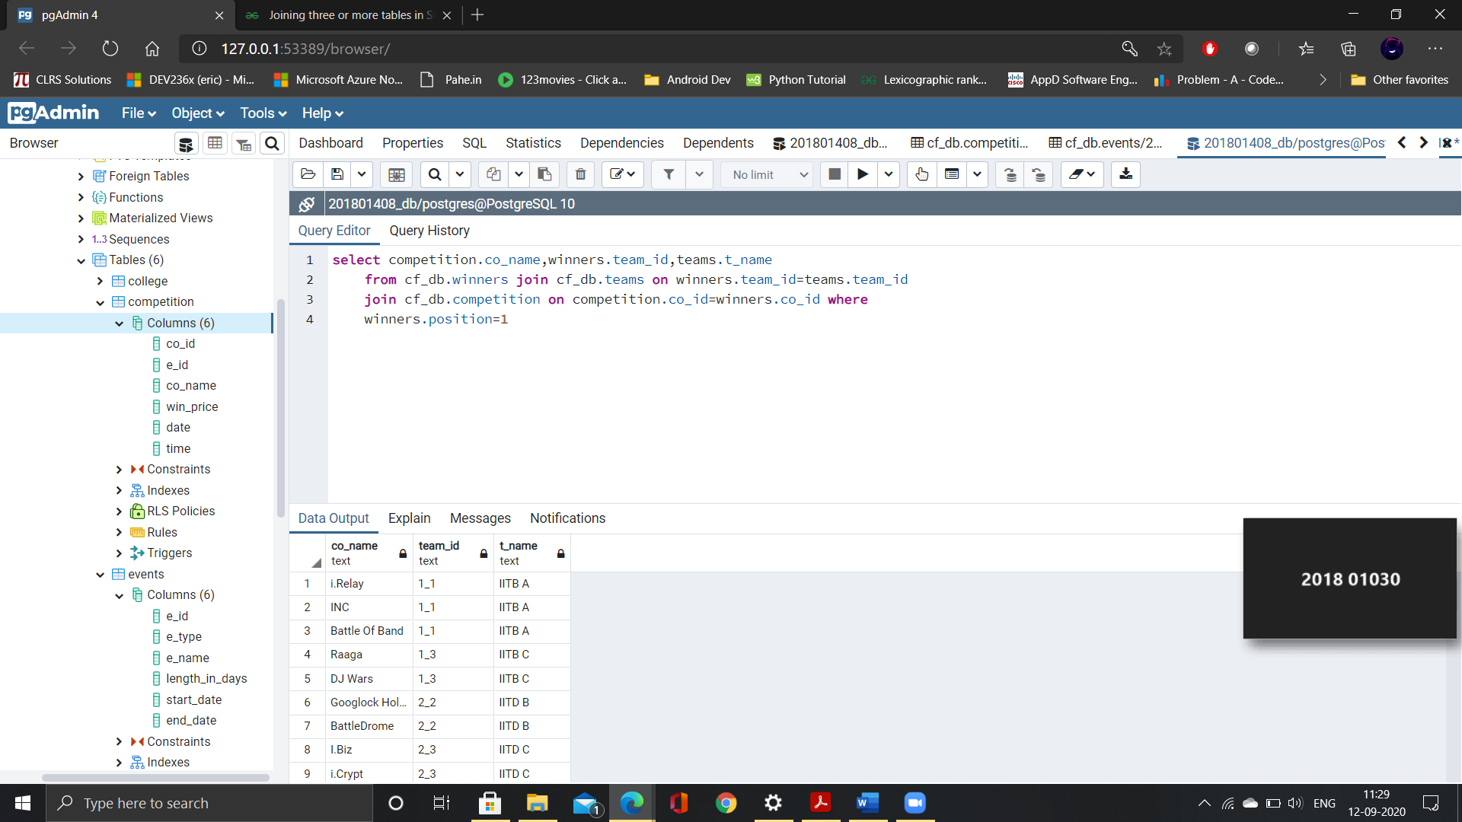

1. **Show list of collages names with no of participants students of respective colleges.**

Select count(students.c_id),college.c_name from cf_db.students join cf_db.college on students.c_id=college.c_id group by college.c_id

**9 rows**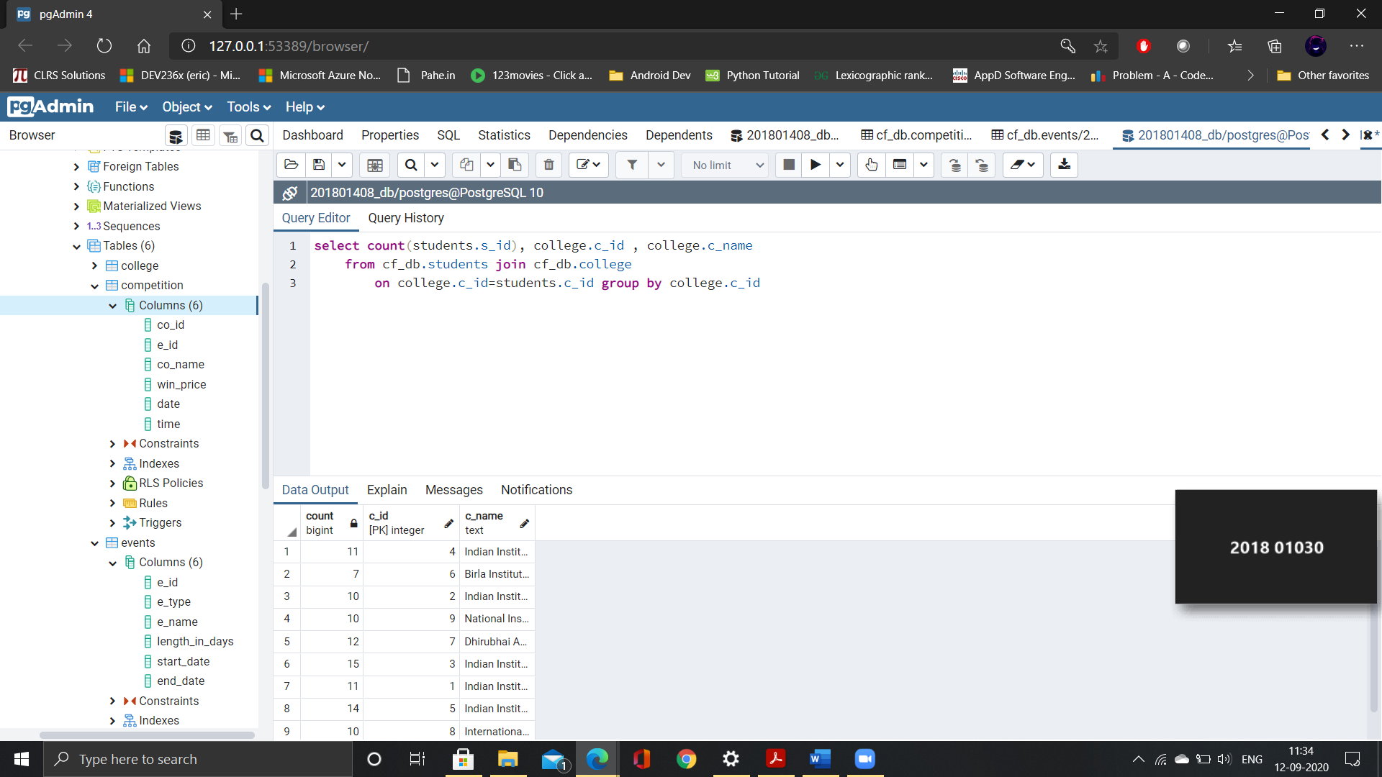

1. **Find out list that contain events name with their respective no of competitions counts.**

Select count(distinct competition.co_name),events.e_name from cf_db.competiton join cf_db.events on competition.e_id=events.e_id group by events.e_name

**3 rows**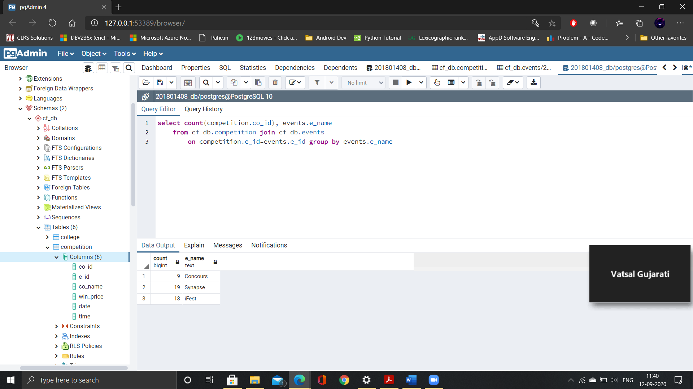

1. **Show list of collages names with no of participants students of respective colleges greater than 10.**

Create view q13 as select count(students.s_id),college.c_name from cf_db.students join cf_db.college on students.c_id=college.c_id group by college.c_name

Select * from q13 where count>10

**5 rows**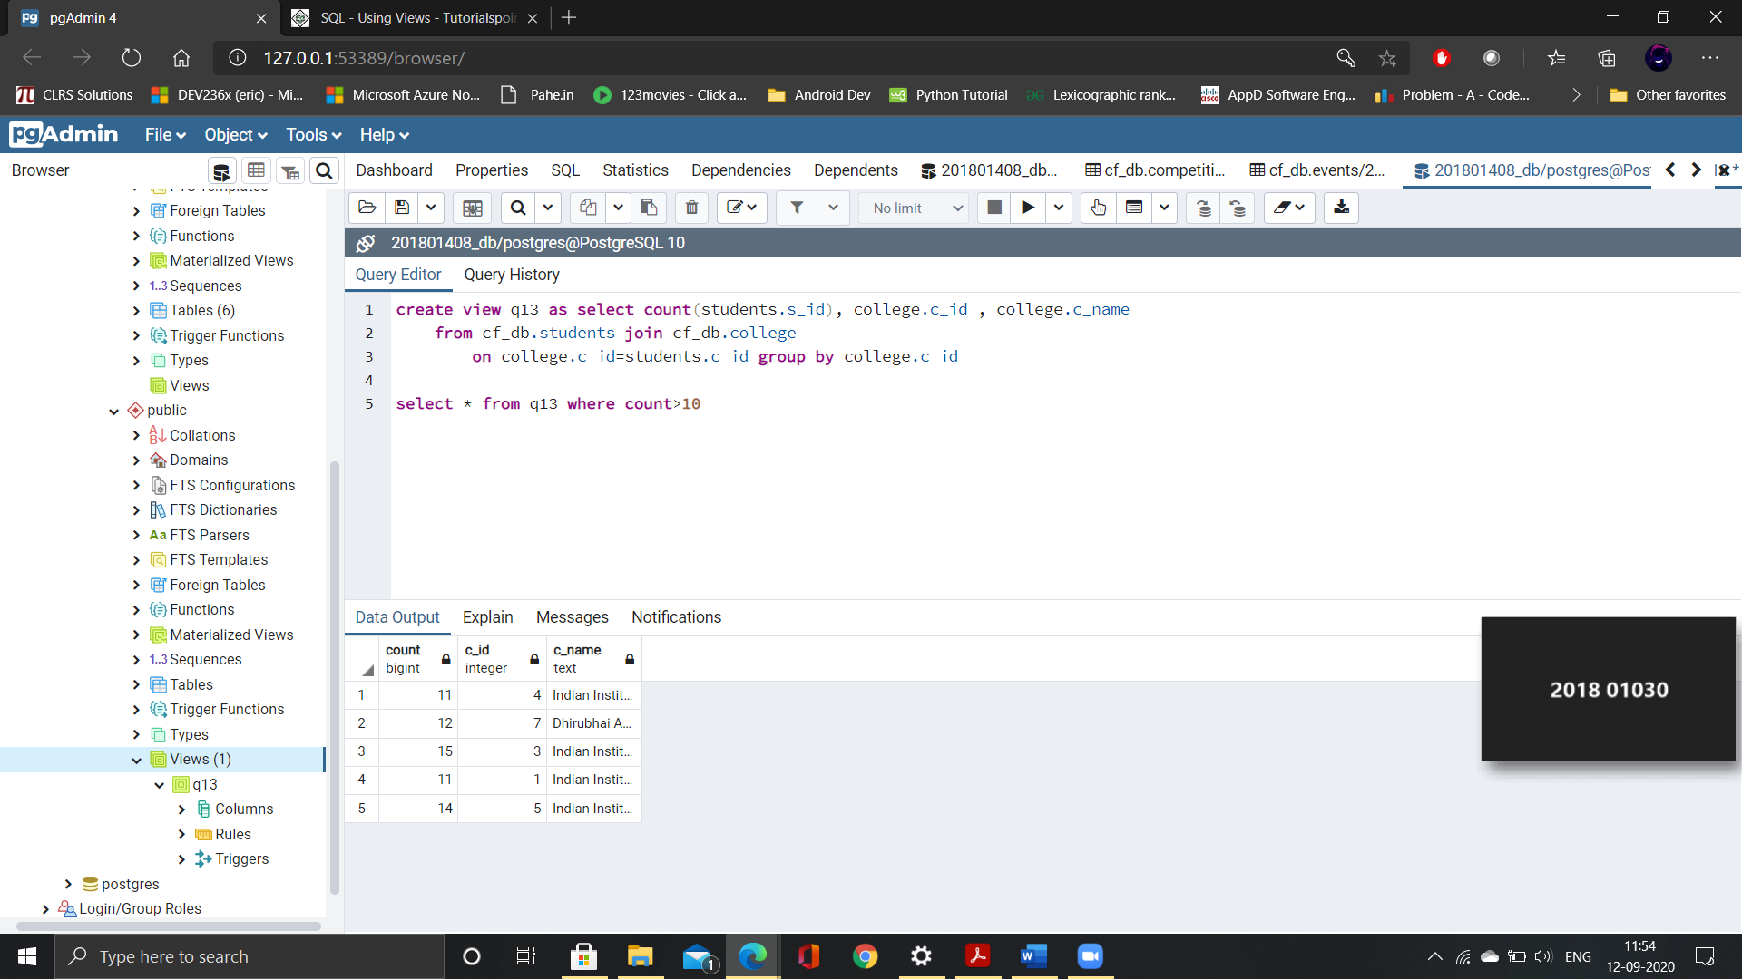

1. **Find the list of team's ids with number of time wining for different competitions and which are winners of more than 3 competitions (consider top 3 place)**

Create view q14 as select count(winners.position),team_id from cf_db.winners group by team_id

Select * from q14 where count>3 order by count desc limit 3

**3 rows**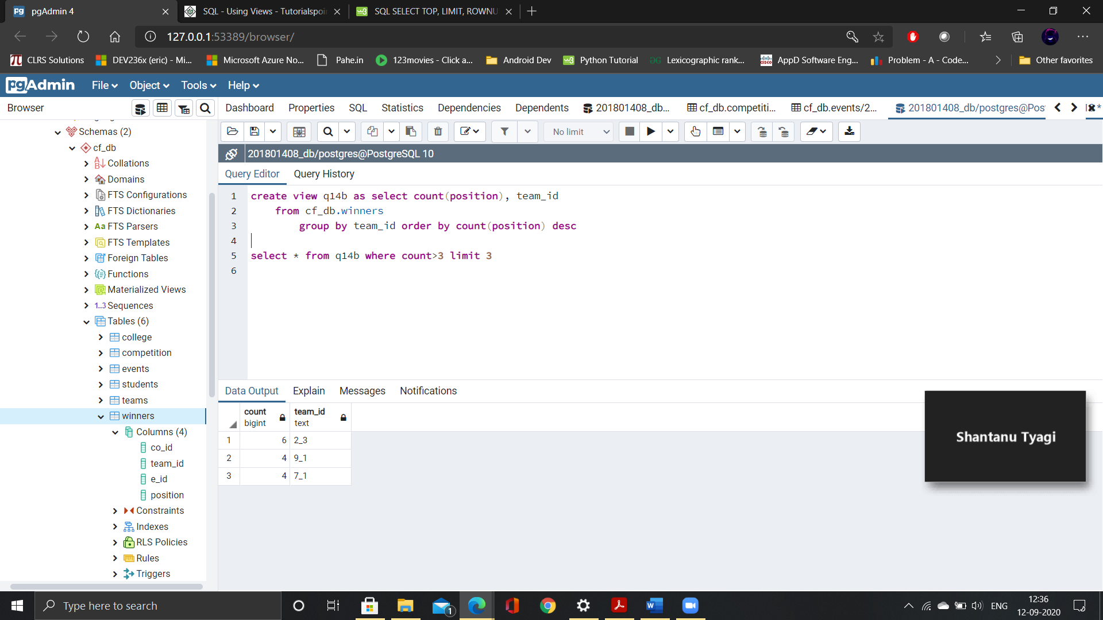

1. **Find the list of dates with no of competitions held respective dates (date , no_of_competitions)**

Select date,count(co_id) from cf_db.competiton group by competition.date

**10 rows**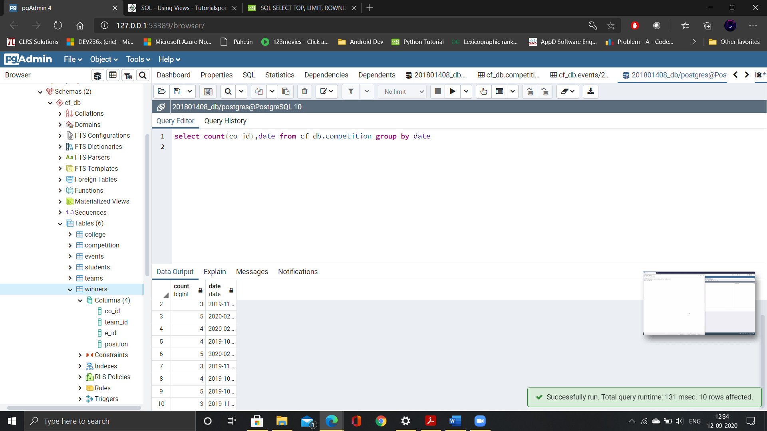

1. **Find the list of dates with no of competitions held respective dates (date, no_of_competitions) and respective events names.**

Select competition.date,count(competiton.co_id),events.e_name from cf_db.competiton join cf_db.events on competition.e_id=events.e_id group by competition.date,events.e_name

**10 rows**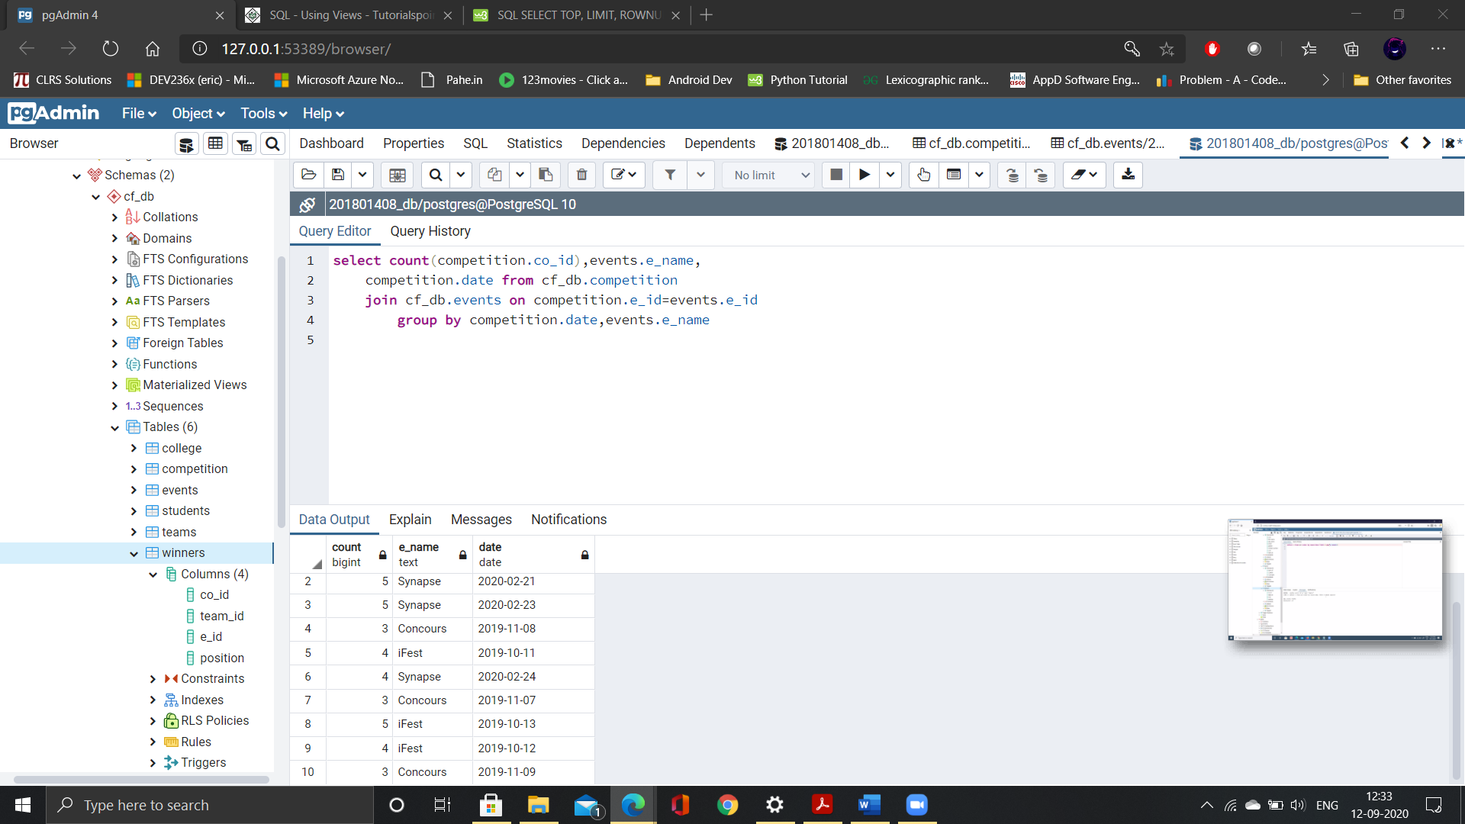

1. **Find the team id which are most times winners of competitions (consider top 3 place for winners)**

Select team_id from q14 where count=(select max(count) from q14)

**1 row**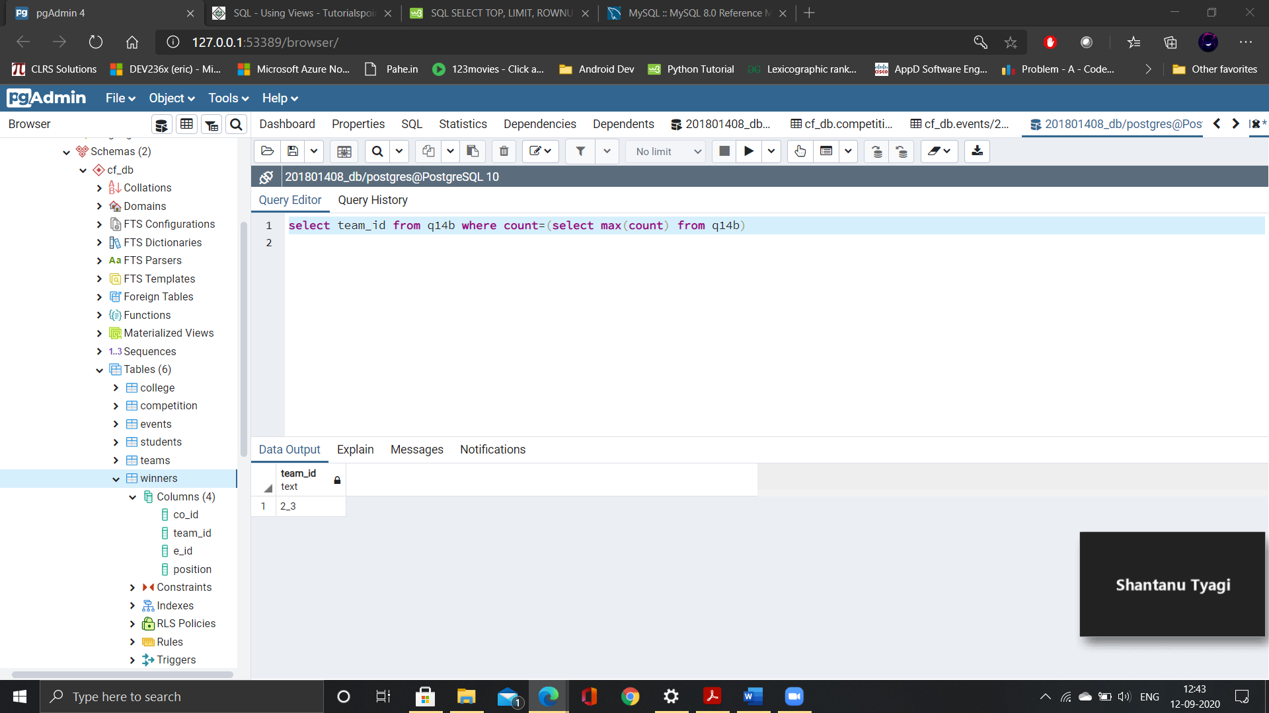

1. **Find the team ids which are not winners of any competitions (consider top 3 place for winners).**

Select team_id from cf_db.teams except select distinct winners.team_id from cf_db.winners

**2 rows**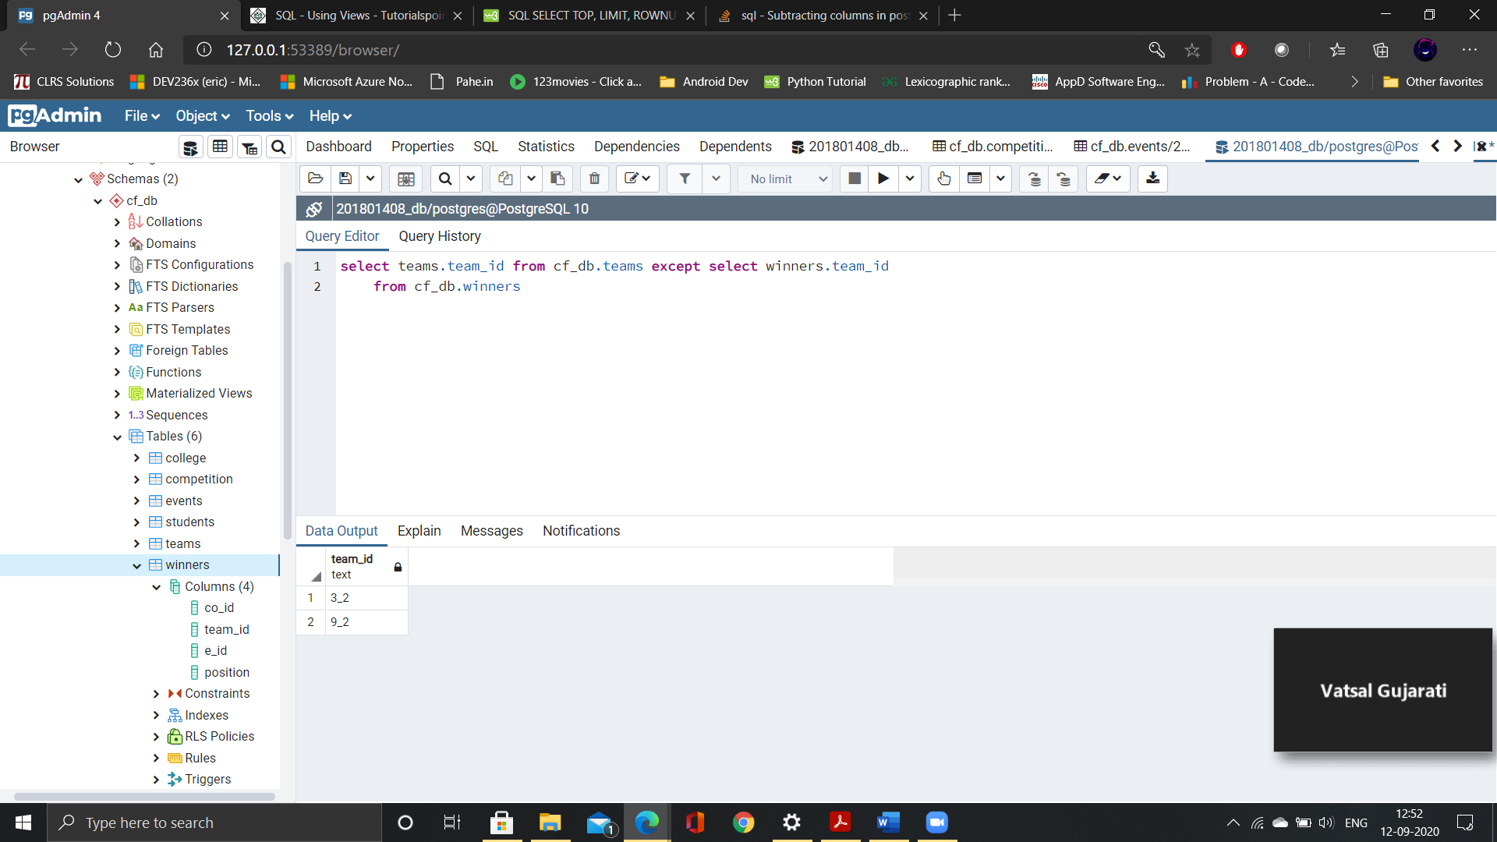

1. **Find the competition name which have second highest wining price.**

Select co_name from cf_db.competition where win_price=(select max(win_price) from cf_db.competition where win_price<(select max(win_price) from cf_db.competition))

**2 rows**

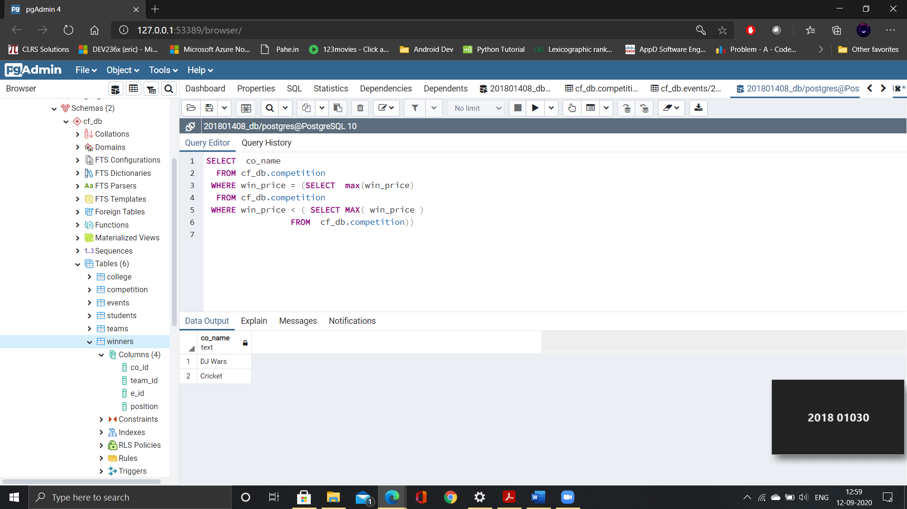

1. **Find the list of events with highest wining price of their respective event’s competitions**

Select events.e_name max(competition.win_price) from cf_db.events join cf_db.competition on events.e_id=competition.e_id group by events.e_name order by max(competition.win_price) desc

**3 rows**

